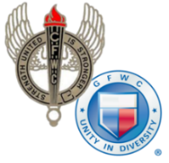
CALIFORNIA FEDERATION OF WOMEN’S CLUBS

DISTRICT AWARD ENTRY COVER SHEET
Annual Reporting January 1-December 31, 2022
Chairman:
District: |  | Area:
Reporter’s Address:
City: | State: | Zip:
Email: | Phone:
__________________________________________________________________________________________
Name of GFWC Special Program, Community Service Program, Advancement Plan or ESO
Entries may be no more than 3 pages (including this cover sheet), single spaced, no smaller than 11pt font. Begin with 1 paragraph describing your district. Describe district projects that made the most impact in your community (who, what when where, how and why). Submit entry forms to your district dean by the date assigned by your district.
Include this HEADER for each project described: Project Title Hours Donated $ In Kind $______
(Begin Narrative Below)

