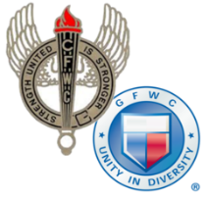
CALIFORNIA FEDERATION OF WOMEN’S CLUBS

DISTRICT AWARD ENTRY COVER SHEET
Annual Reporting January 1-December 31, 2021

Chairman:
District: |  | Area:
Reporter’s Address:
City: | State: | Zip:
Email: | Phone:
__________________________________________________________________________________________
Name of GFWC Special Program, Community Service Program, Advancement Plan or ESO
Entries may be no more than 3 pages, single spaced, including this cover sheet. At the beginning, include one paragraph describing your district. Submit entry to your district dean by the date assigned by your district. Describe projects that made the most impact in your community (who, what when where, how and why).
Include this HEADER for each project described: Project Title Hours Donated $ In Kind $____

(Begin Narrative Below)

