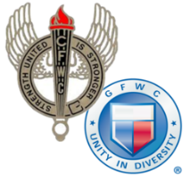
CALIFORNIA FEDERATION OF WOMEN’S CLUBS

CLUB AWARD ENTRY COVER SHEET
Annual Reporting January 1-December 31, 2021

Chairman: | Club:
Number of Members (from CFWC Yearbk): | District: | Area:
Reporter’s Address:
City: | State: |  | Zip:
Email: | Phone:
__________________________________________________________________________________________
Name of GFWC Special Program, Community Service Program, Advancement Plan or ESO

Entries may be no more than 3 pages, single spaced, including this cover sheet. At the beginning, include one opening paragraph describing your club. Submit entry to your district dean by the date assigned by your district. Describe club projects that made the most impact in your community or club (who, what when where, how and why).
Include this HEADER for each project described: Project Title Hours Donated $ In Kind $____
(Begin Narrative Below)

